# **Road Traffic Crash in Nigeria Data Analysis**

## Introduction

According to the Federal Road Safety Corps, road traffic crash is among the leading cause of death in Nigeria apart from insurgency and banditry. Road crashes are identified as one of the leading causes of death in Nigeria. In 2016, the Word Economic Forum noted that road traffic deaths are the eighth leading cause of death. Data from the Federal Road Safety Corps and the National Bureau of Statistics says between 2013 and 2020, at least 41,709 persons have lost their lives to road crashes in Nigeria.

Tools Used: Excel and Power BI

## Objective

To identify the most significant recurrent patterns and the most significant cause of road traffic crashes in Nigeria.

## Data Collection

I collected the data I used from Federal Road Safety Corps website which keeps records of road accidents for every state in the country.

The road traffic crash data contains total cases, total casualty, causative factors, vehicle category, people involved, number of people injured, number of people killed and sex distribution of people killed.

# Data Cleaning and Modelling

The dataset was provided in excel tables. The data has records of road traffic crash in all the states in Nigeria from October 2020 to March 2022. It has different tables, part of the cleaning was done in excel. I dropped the frequency columns for each table as they are not necessary for the analysis. There were a lot of duplicate columns but no record of null values. I imported the data into Power BI for further cleaning and visualization. I merged the duplicate columns and renamed the columns to reduce redundancy using power query.

I created new measures for Total case, Total Casualty, Total number of vehicles, Total Fatal, Total serious and minor casualty to have a clear picture from the data.

## Data Visualization

The visualization revealed many facts hidden in the data.

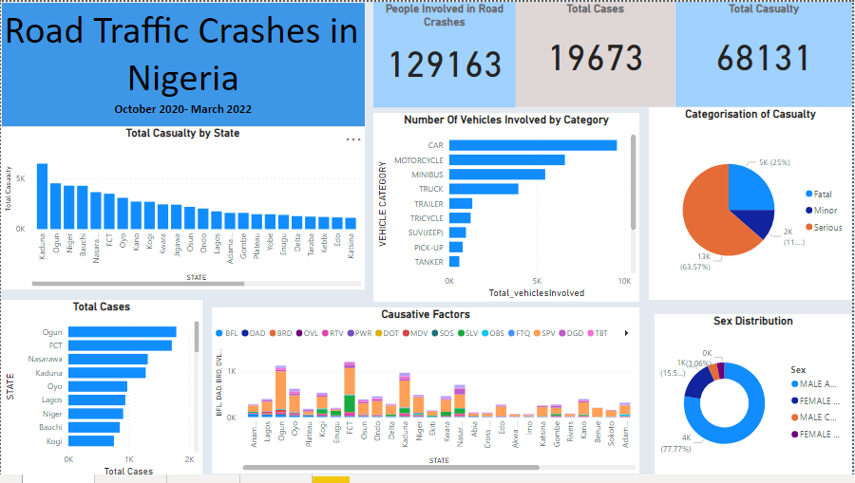

129163 people were involved in the road traffic crash during this period. The total cases of road crash from October 2020 to march 2022 was 19673 with 68131 total casualties. 58424 people were injured while 9707 people died.

# Insights From Data Visualization

1. RTC on State Basis

Analysis shows that the highest cases recorded in the country during this period happened in Ogun State with 1788, followed by FCT with 1714 cases. Nasarawa and Kaduna came third and fourth with 1316 and 1282 cases respectively. Bayelsa and Akwa ibom has the least cases with 78 and 111 cases.

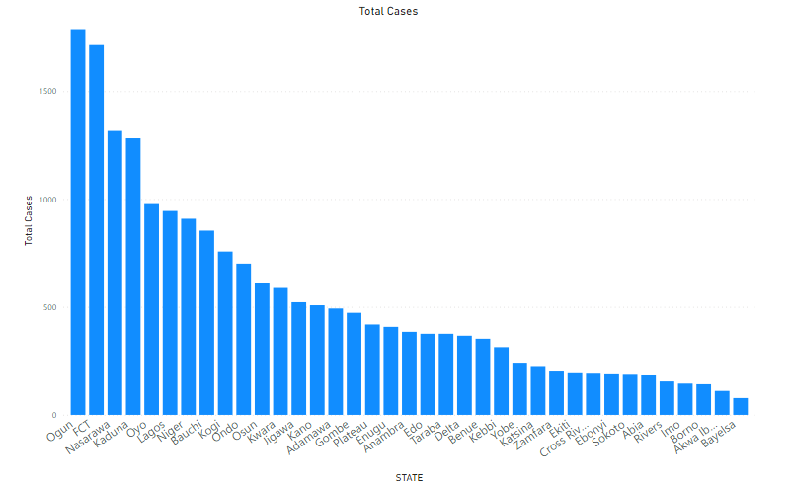

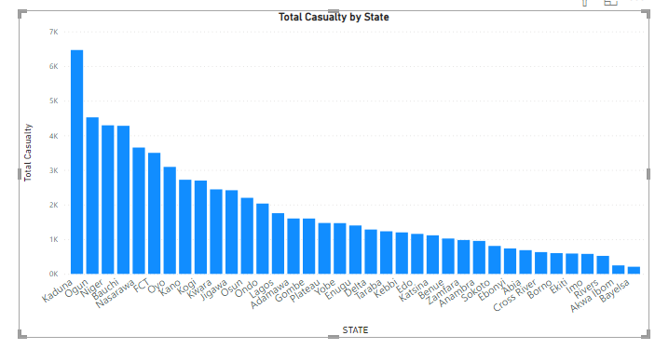

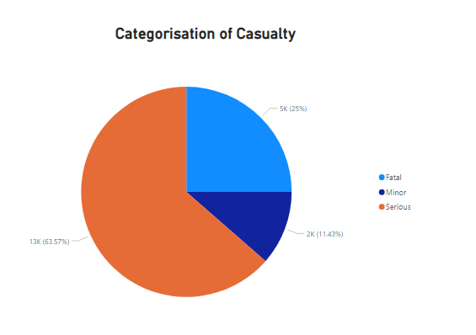

2. Number of Vehicles involved by Category

Motor car accidents was 9592 which is the highest among the vehicle category followed by motorcycles with 6618 cases. Minibuses, truck and trailer came third, fourth and fifth with 5492, 3959 and 1324 cases respectively. Luxury buses and Bicycles have zero record of accident.

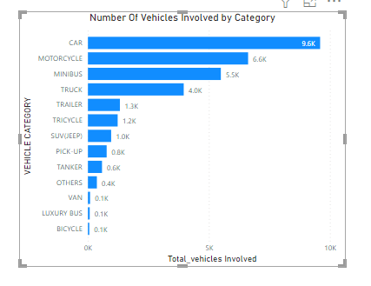

3. Sex Distribution Vs People Killed

Male adults accounted for 77.77% that died from road accidents while female adults were 15.51%. For children, the percentage of females was more than that of the males.

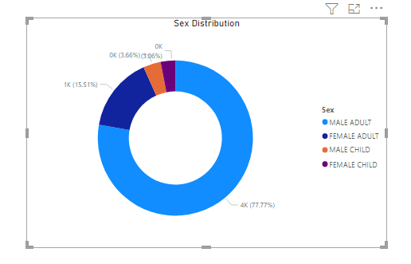

4. Causative Factors Vs RTC

The major cause of road traffic crash in Nigeria are speed violations, sign light violations, wrongful overtaking mechanical deficient vehicle, brake failure and bad road.

|  |  |
| --- | --- |
| CAUSATIVE FACTORS | CODE |
| Speed Violation (SPV) | SPV |
| Use of Phone While Driving (UPWD) | UPWD |
| Tyre Burst (TBT) | TBT |
| Mechanically Deficient Vehicle (MDV) | MDV |
| Brake Failure (BFL) | BFL |
| Overloading (OVL) | OVL |
| Dangerous Overtaking (DOT) | DOT |
| Wrongful Overtaking (WOT) | WOT |
| Dangerous Driving (DGD) | DGD |
| Bad Road (BRD) | BRD |
| Route Violation (RTV) | RTV |
| Road Obstruction Violation (OBS) | OBS |
| Sleeping on Steering (SOS) | SOS |
| Driving Under Alcohol/Drug Influence (DAD) | DAD |
| Poor Weather (PWR) | PWR |
| Fatigue (FTQ) | FTQ |
| Sign Light Violation (SLV) | SLV |
| Others | OTH |

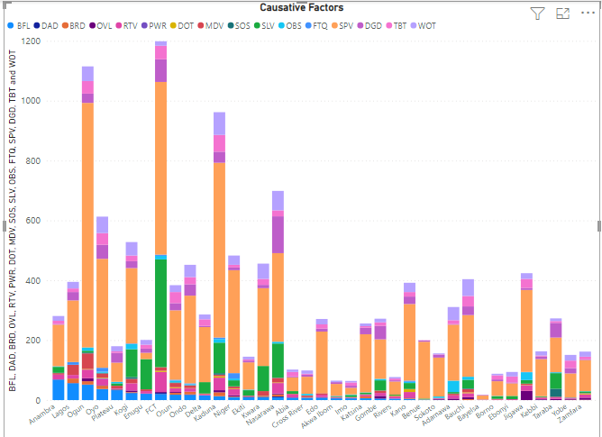

# Conclusion and Recommendation

The main cause of road accident in Nigeria is speed violation, traffic laws should be put into place for road users. The Road Traffic Crash Analysis and the data visualization can help government, policy makers, road engineers to devise useful prevention and to make strategic plans to identify lapses in the current road system and traffic laws.